(Approx.189 words)

Enacfire A9 Active Noise Cancelling Wireless Earbuds
By George Harding, Treasurer, Tucson Computer Society
https://aztcs.apcug.org/
actuary110 (at) yahoo.com

These earbuds include active noise cancellation and smart noise-detect mics that distinguish ambient noises and offset them before they reach the ear. As a result, they reduce outside noise up to 80%.

An extra feature allows users to hear external sounds when desired, without pausing music or taking the earbuds out. This safety feature lets you hear vehicle noise, sirens, etc., when you want to.

The innovative microphones can pick up cell phone call voices with crystal clear audio quality, including deep bass and extra loud sound if desired.

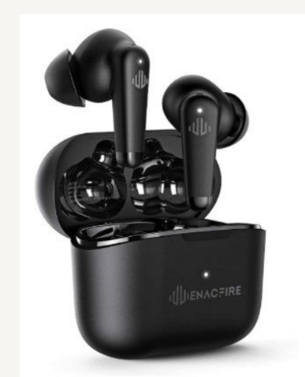

The earbuds are designed to stay secure even during intense exercise yet provide hours of comfortable wear. The stylish charging case provides 32-hour playtime, accompanying you for long-haul flights across the continent. They keep you from all the chaos throughout the way.

The case charges the earbuds but itself is charged with fast USB-C technology.

The Bluetooth facility is built-in, and it allows quick and easy pairing with your devices.

ENACFIRE A9 active noise canceling wireless earbuds:

https://enacfire.com/collections/enacfire-wireless-earbuds/products/enacfire-a9-wireless-earbuds

Priced at about $60

